**Java Installation Steps:**

Before Installation:

Step1: Open command prompt and check for javac and java command, If java is not installed we see below message “java is not recognized as an internal or external command”

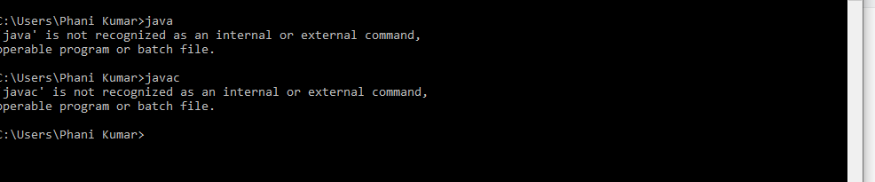

For java download go to below page and download.

In Oracle page:

<https://www.oracle.com/in/java/technologies/downloads/#jdk17-windows>

download below installer for java17:  
  
<https://download.oracle.com/java/17/latest/jdk-17_windows-x64_bin.exe>

below file will be downloaded:  
  
jdk-17_windows-x64_bin.exe

install this by clicking next next.

Once installation is completed go to command prompt and check for both java and java path.

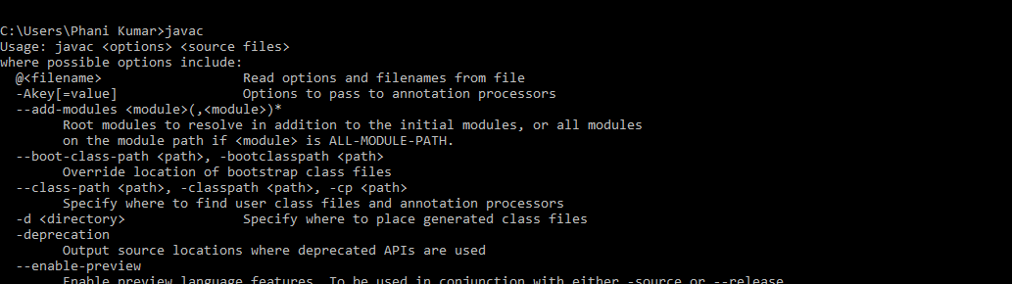

Run first app using command prompt

Create a java file in any location.

Ex:

Created a Main.java file in below path.

File contains below code

class Main

{

public static void main(String args[])

{

System.out.println("Hello java!@@@@@@@@@@@");

}

}

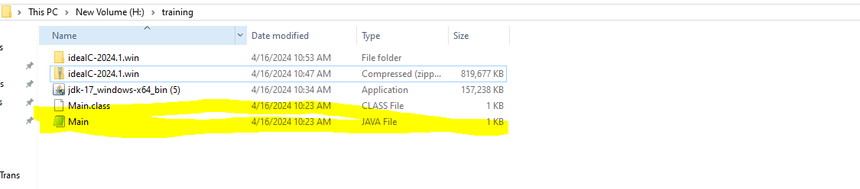

Run the app:

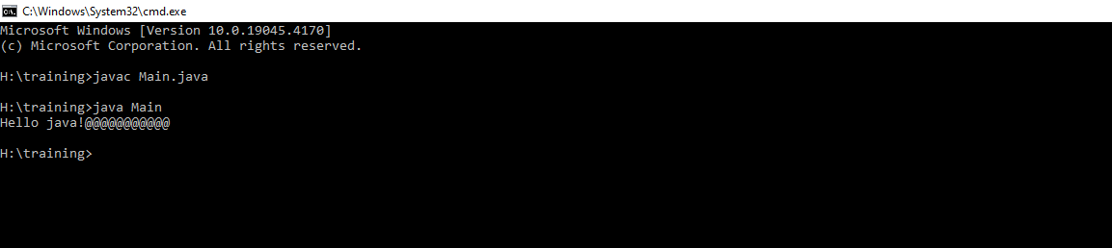

Will get below output;

==================================================================================

**IntelliJ Idea Installation Steps:**

Go to

<https://www.jetbrains.com/idea/download/?section=windows>

download below community edition zip file:

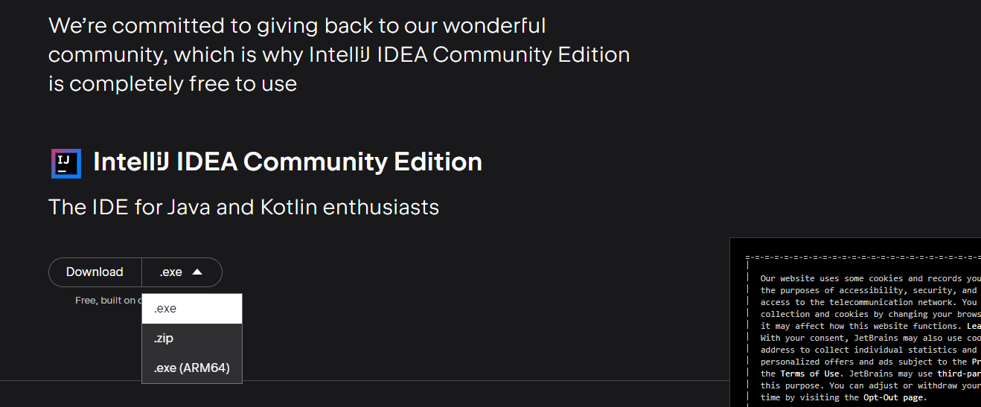

Below file will be downloaded



Extract the above file.

After extracting we see below folder structure

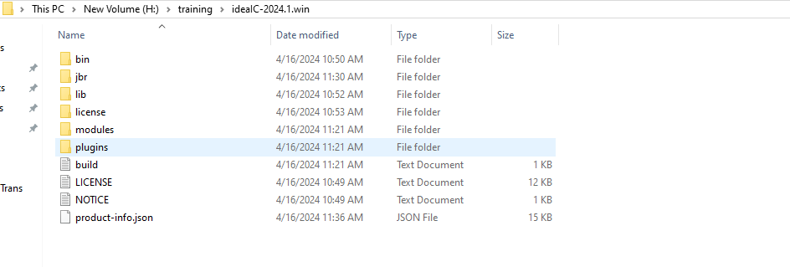

Goto bin location and open below app

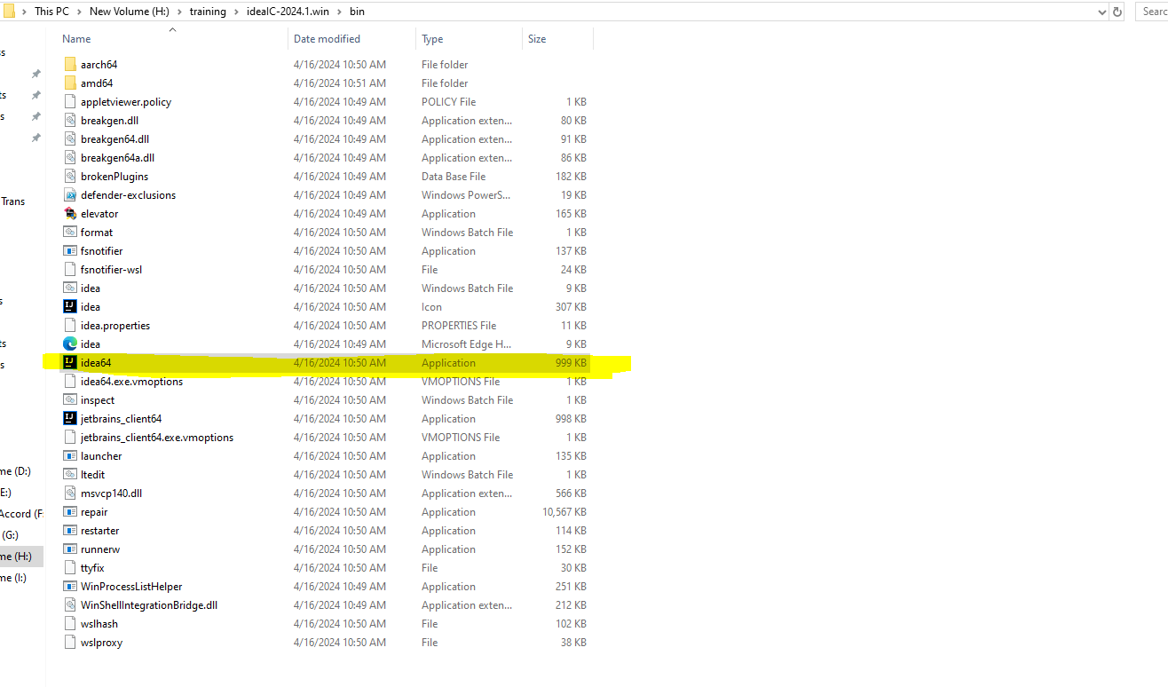

Run sample app like below

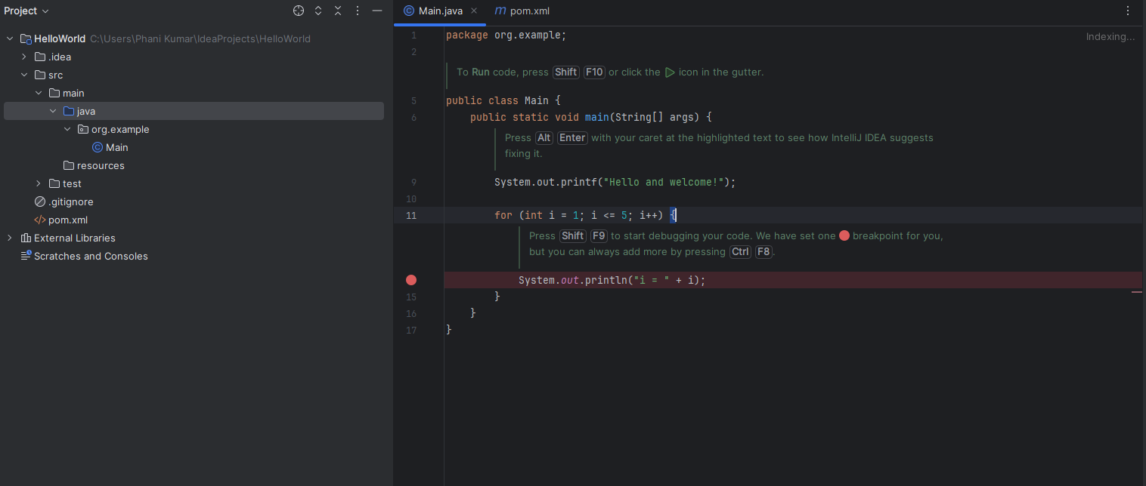

Will execute sample in live class.